1) Show the results for all images in the case of 3D data points as well as 5D data points (using a fixed value of K). Discuss the results. Which data representation is better in your opinion?

2) Apply different values of K to the image mm.jpg and show the results for both 3D and 5D data points. Interpret the results.

3) Where do you see - based on your results - the strengths and the weaknesses of the method?
K = 4

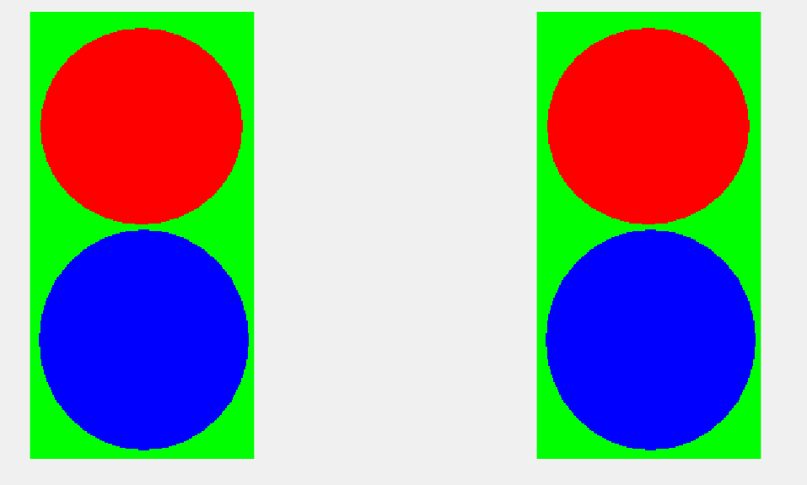







k = 5



k = 10


K = 15

K = 25

K = 40


